SQL Exercise

1. List of the employees who are working on BRO Recruitment project

**select employee.first_name, employee.mid_name, employee.last_name, project.name**

**from employee**

**join project on employee.id = project.id**

**where project.name = 'BRO';**

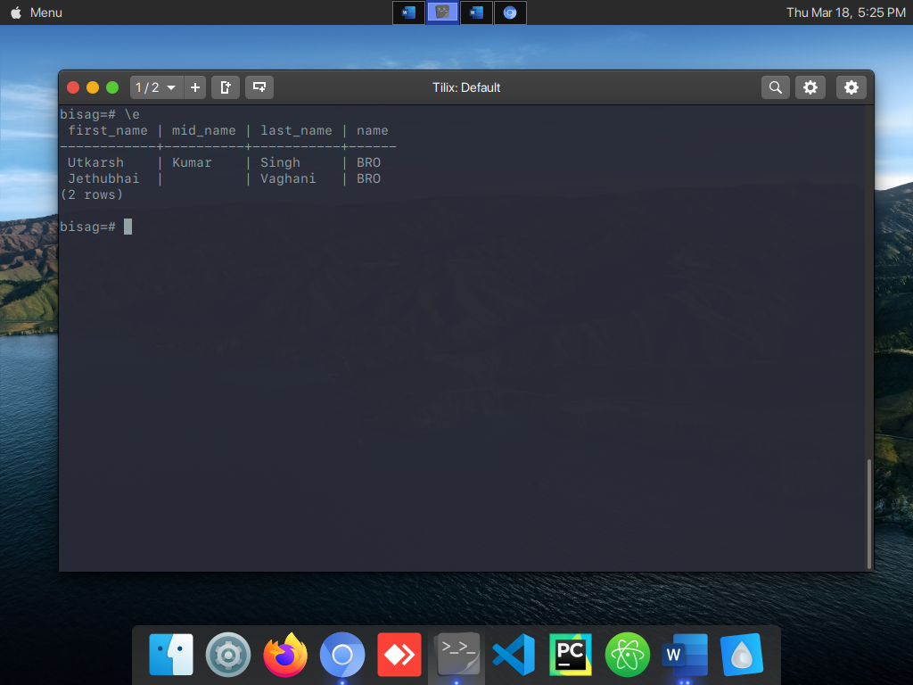

2. List of the employees who are not working on EME Project.

**select employee.first_name, employee.mid_name, employee.last_name, project.name**

**from employee**

**join project on employee.id = project.id**

**where project.name != 'BRO';**

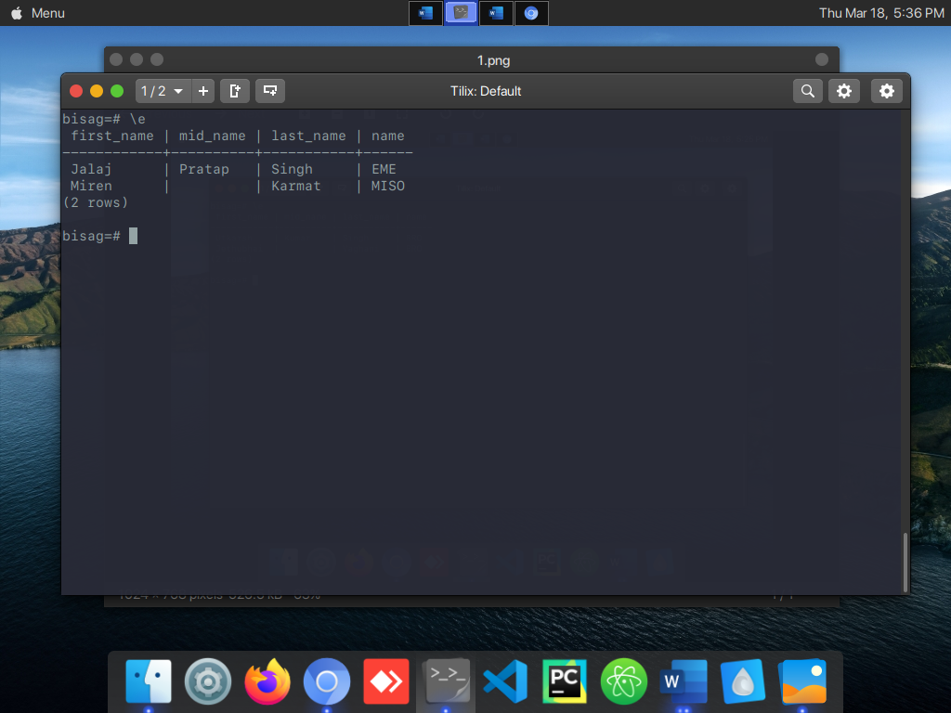

3. List of the employees whose experience is more or equal to 2 years in descending order.

**select employee.first_name, employee.mid_name, employee.last_name,**

**extract(year from age(current_date, doj)) as total_exp, project.name**

**from employee**

**join project on employee.id = project.id**

**where extract(year from age(current_date, doj)) >= 2**

**order by doj desc;**

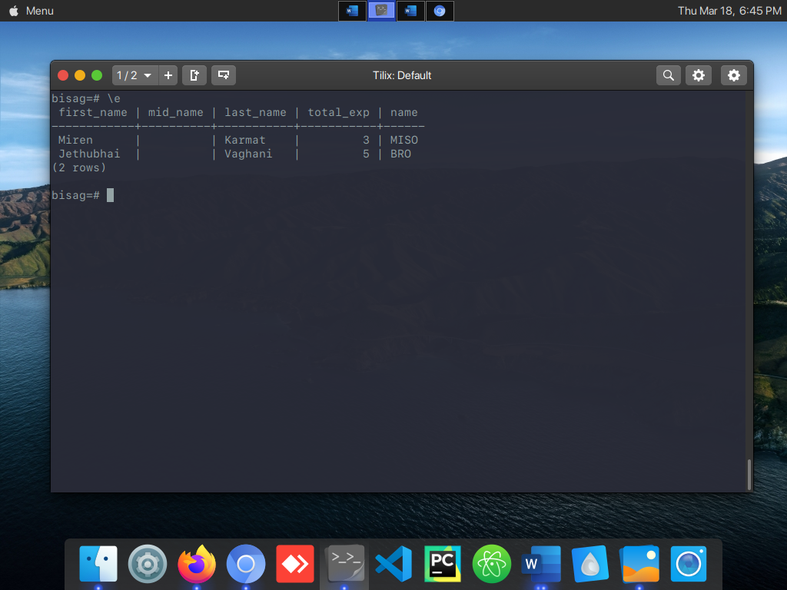

4. List of the employees whose salary is less than 20,000 Rs.

**select employee.first_name, employee.mid_name, employee.last_name, salary from employee**

**where salary < 20000;**

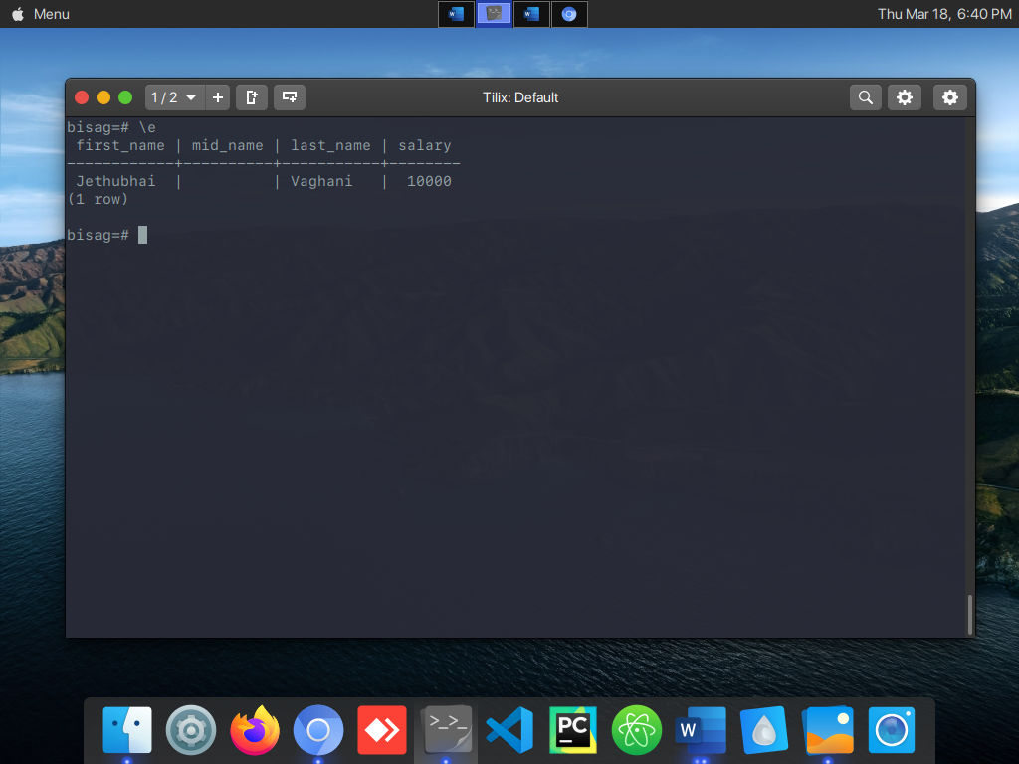

5. List of the employees whose salary is more than 20,000 Rs.

**select employee.first_name, employee.mid_name, employee.last_name, salary**

**from employee**

**where salary > 20000;**

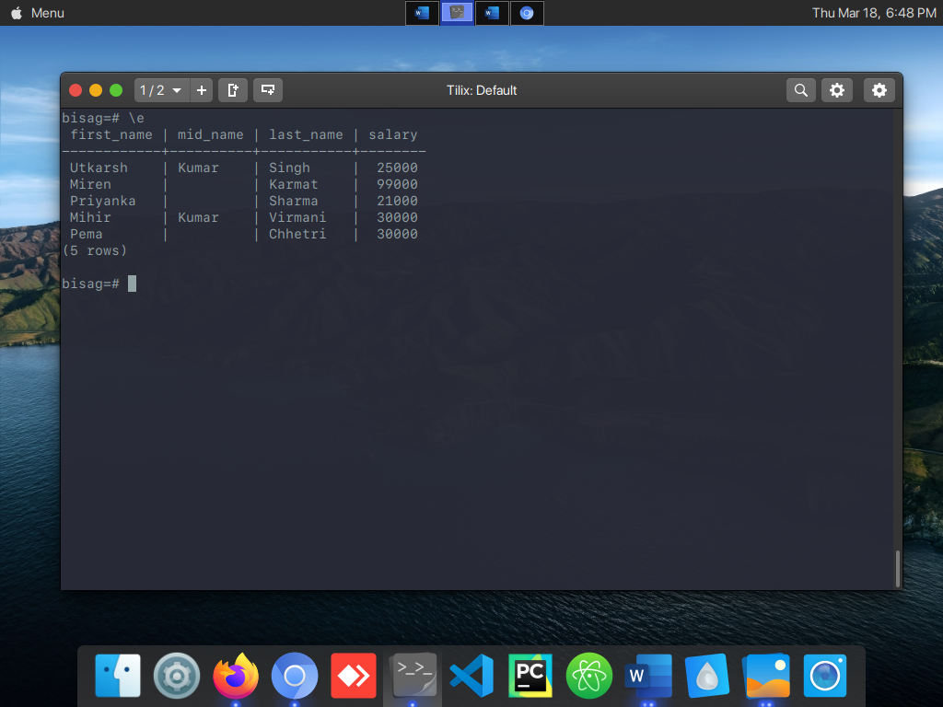

6. List of the employees whose salary in between of 10,000 to 50,000 Rs.

**select employee.first_name, employee.mid_name, employee.last_name, salary**

**from employee**

**where salary between 10000 and 50000;**

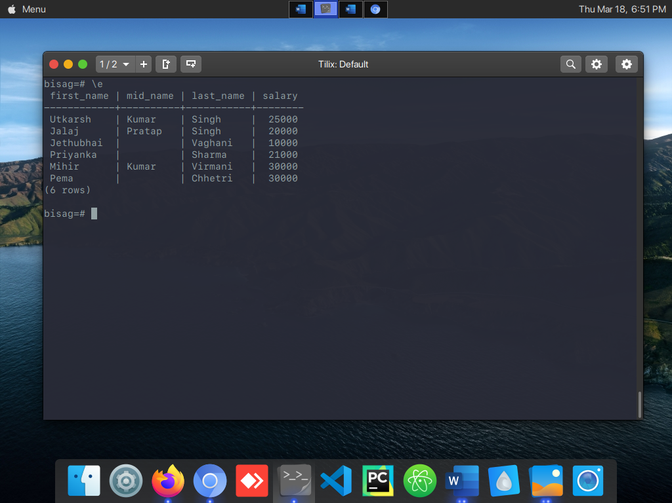

7. List the employee who has a minimum salary.

**select employee.first_name, employee.mid_name, employee.last_name,**

**employee.salary as min_salary**

**from employee**

**where employee.salary = (**

**select min(employee.salary)**

**from employee**

**);**

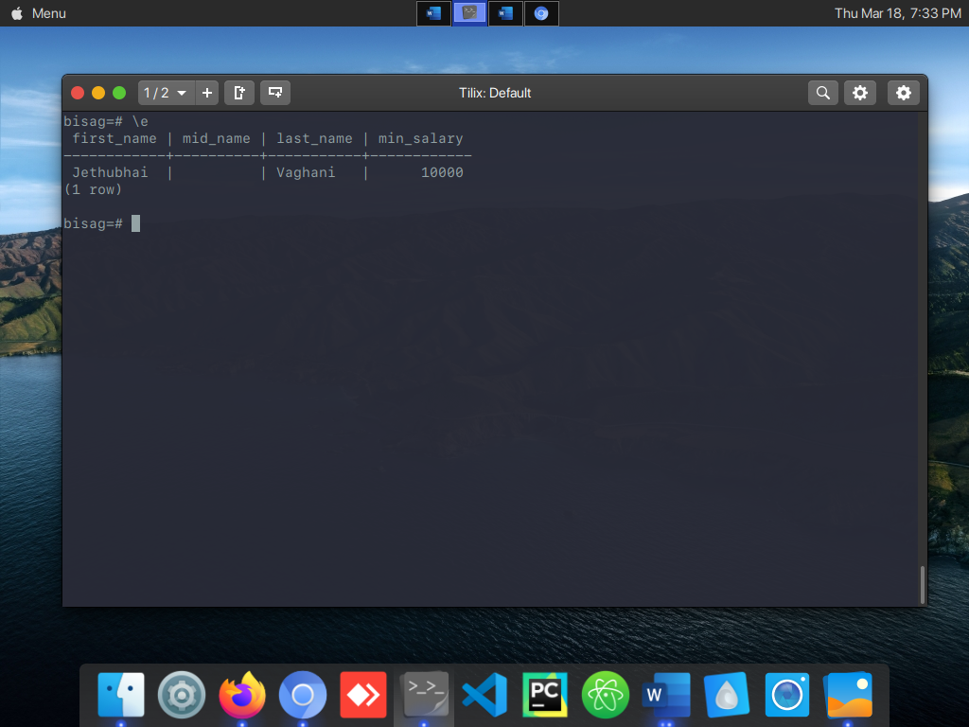

8. List the employee who has a maximum salary.

**select employee.first_name, employee.mid_name, employee.last_name,**

**employee.salary as max_salary**

**from employee**

**where employee.salary = (**

**select max(employee.salary)**

**from employee**

**);**

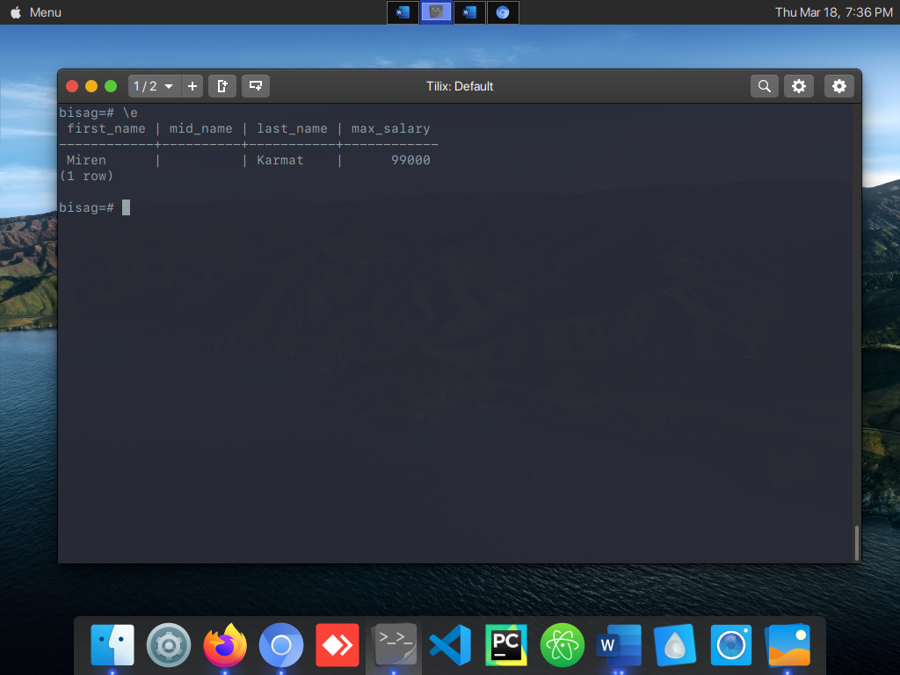

9. Total salary of all employees and the average salary of each employee

**select avg(employee.salary), sum(employee.salary) from employee;**

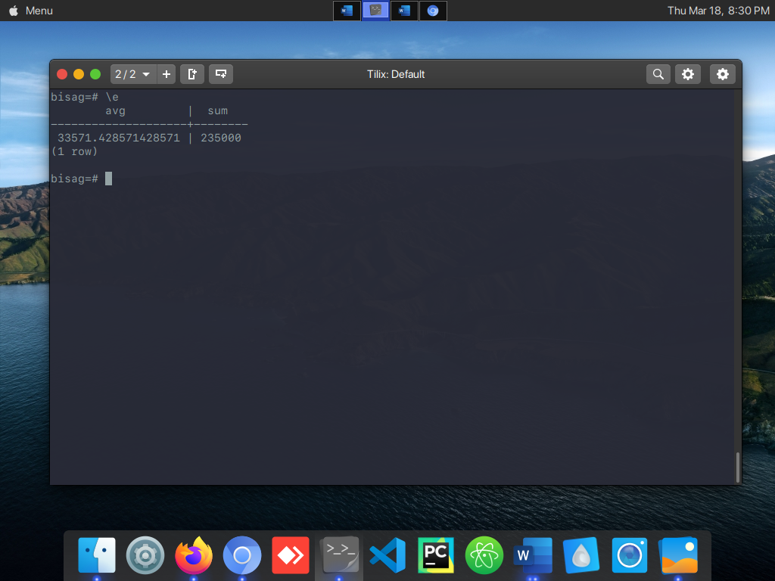

10. List of the employees who are working on diff. project to mention project name in

ascending order and employees name in descending order.

**select employee.first_name, employee.mid_name, employee.last_name,**

**project.name**

**from employee**

**join project on employee.id = project.id**

**order by project.name asc, employee.first_name;**

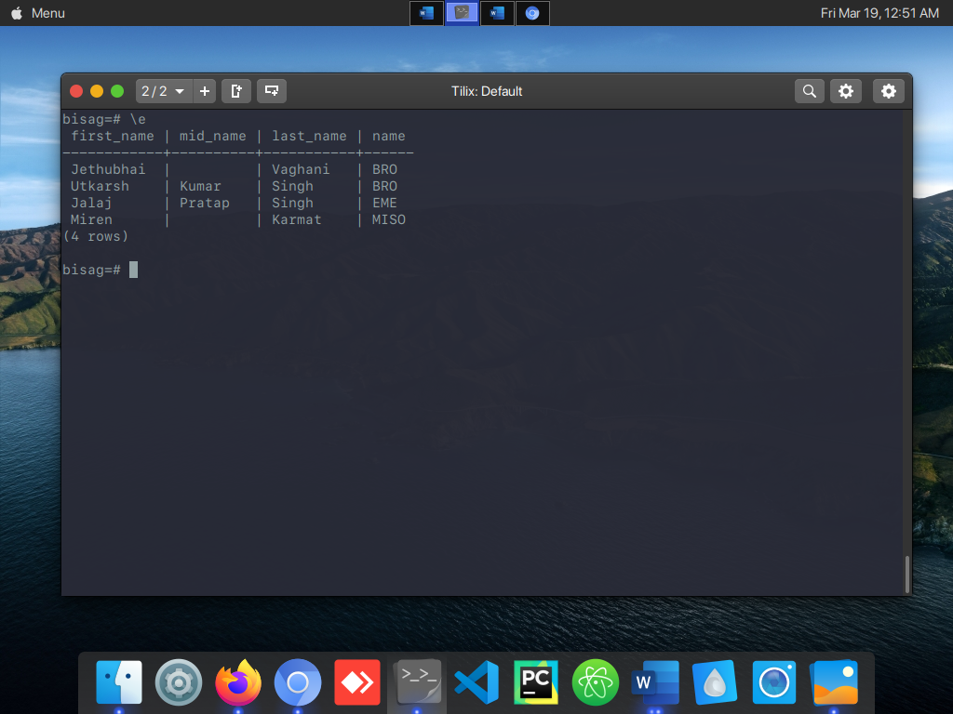

11. List of the employees who joined in the month of July.

12. List of the employees who joined in the year of 2018.

**select e.first_name, e.mid_name, e.last_name, extract(year from doj) as**

**joining_year**

**from employee as e**

**where extract(year from doj) = '2018';**

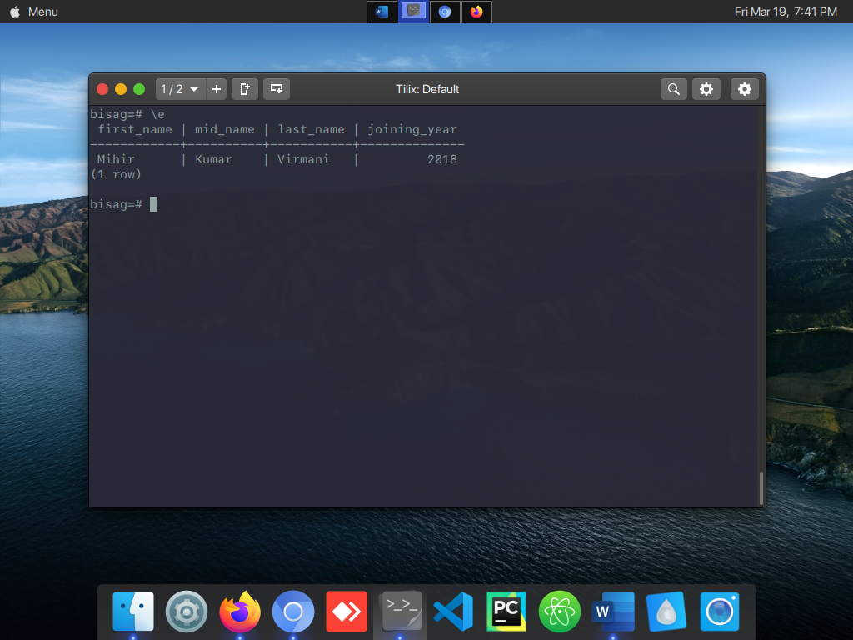

13. List of the employees who are residents of Gandhinagar.

**select e.first_name, e.mid_name, e.last_name, e.curr_loc**

**from employee as e**

**where curr_loc = 'Gandhinagar';**

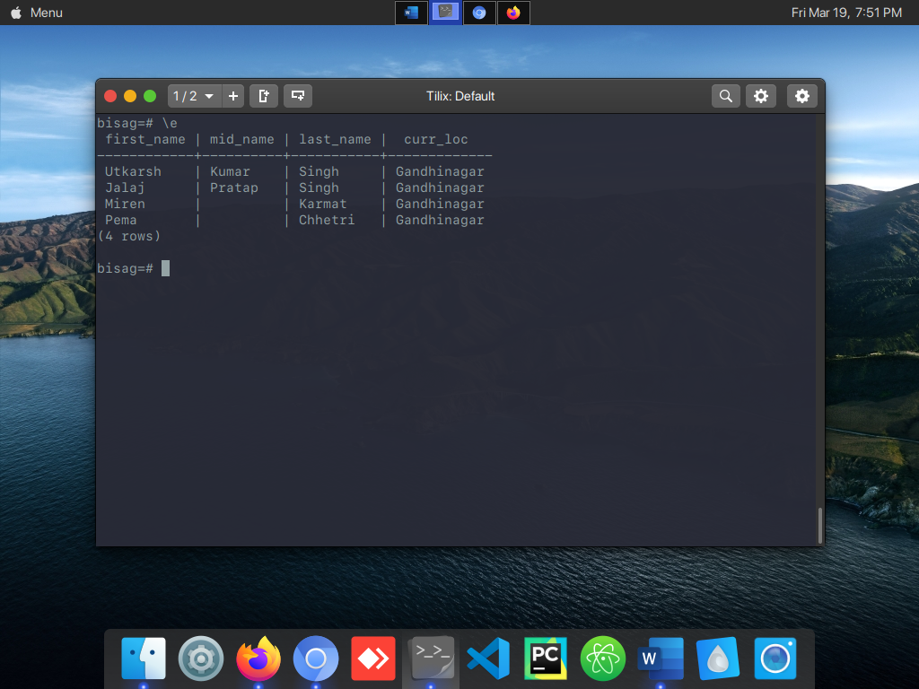

14. List of the employees who up down from different cities to Gandhinagar. (mention cities name)

**select e.first_name, e.mid_name, e.last_name, e.curr_loc**

**from employee as e**

**where curr_loc = 'Gandhinagar';**

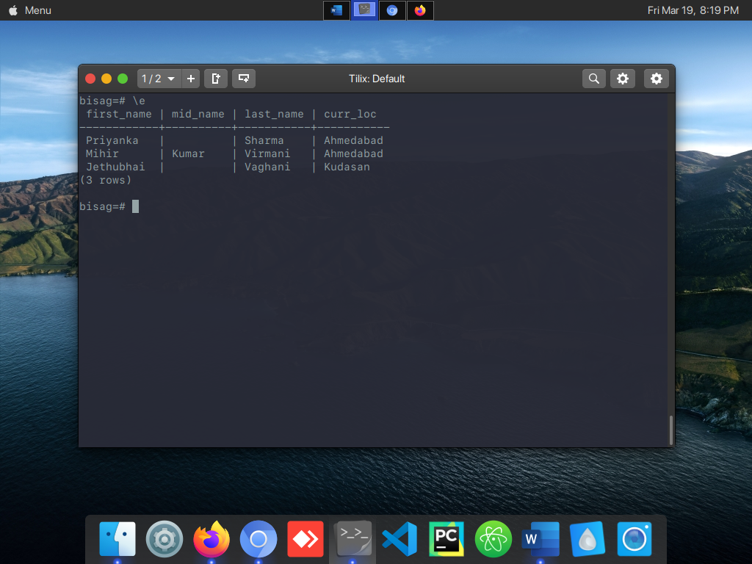

15. No. of Employees based on their technical Qualification(Graduate/Post Graduate)

**select q.type, count(employee.first_name) as count**

**from qualif as q**

**join employee on q.id = employee.qualif_id**

**group by q.type**

**order by q.type desc;**

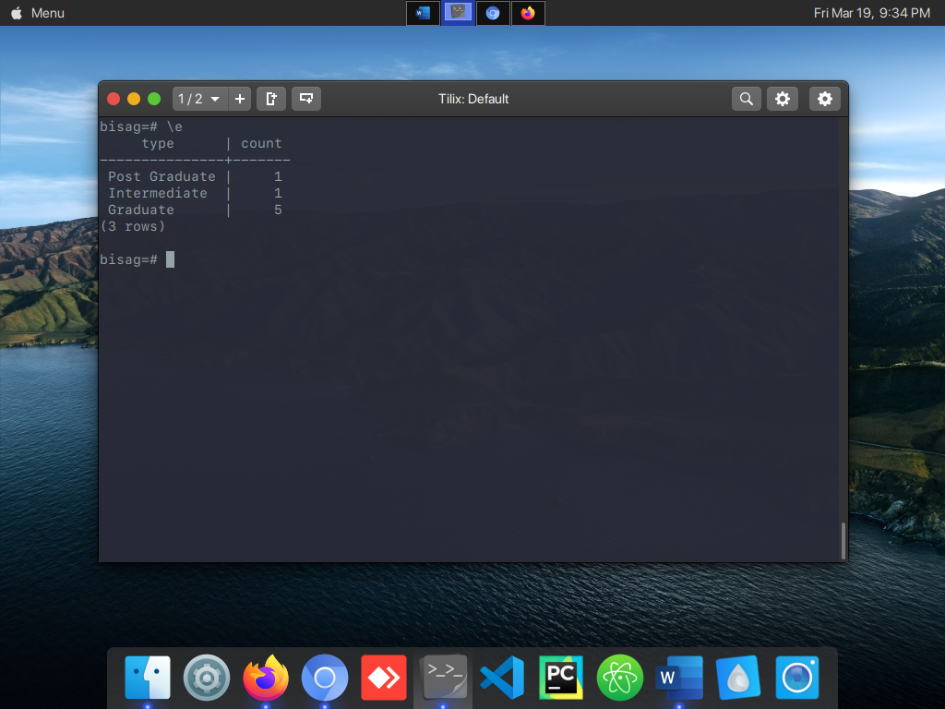

16. The Number of employees in each project were less than 5 number of employees.

17. List the Team Leader name, Project Name and numbers of employees working for those team leaders in ascending order on team leader ID.

**select e.first_name, e.mid_name, e.last_name, project.name, project.num_of_emp**

**from employee as e**

**join project on e.id = project.lead_id**

**order by e.first_name asc;**

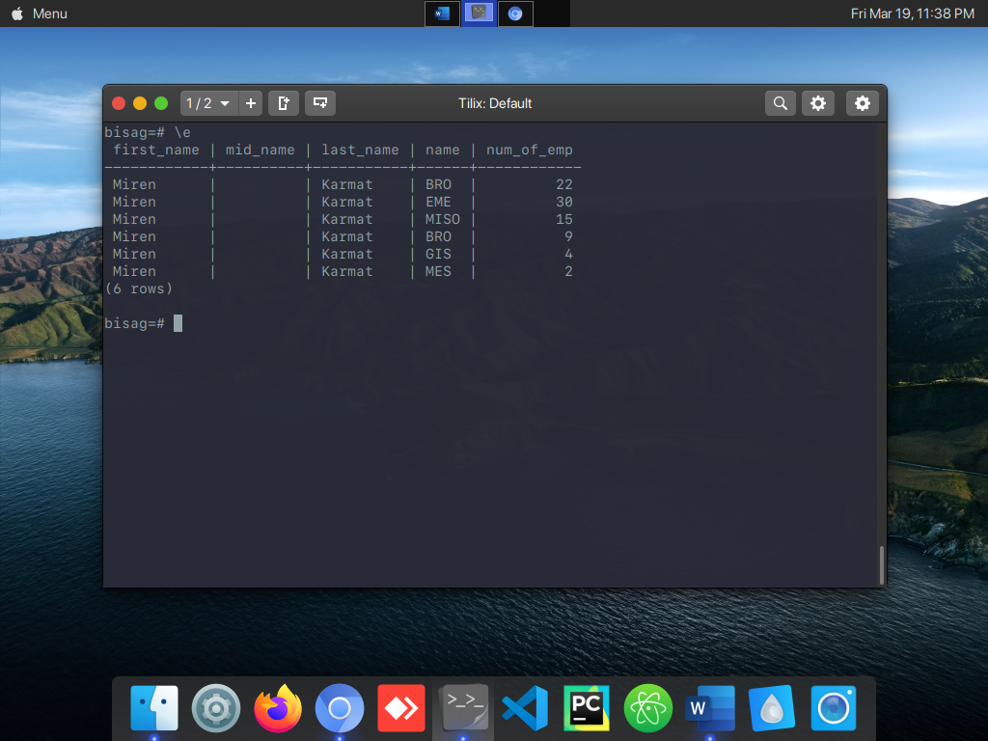

18. List of the employees whose name having more or equal to six characters limit to 5 employees.

**select e.first_name, e.mid_name, e.last_name**

**from employee as e**

**where length(e.first_name) > 5;**

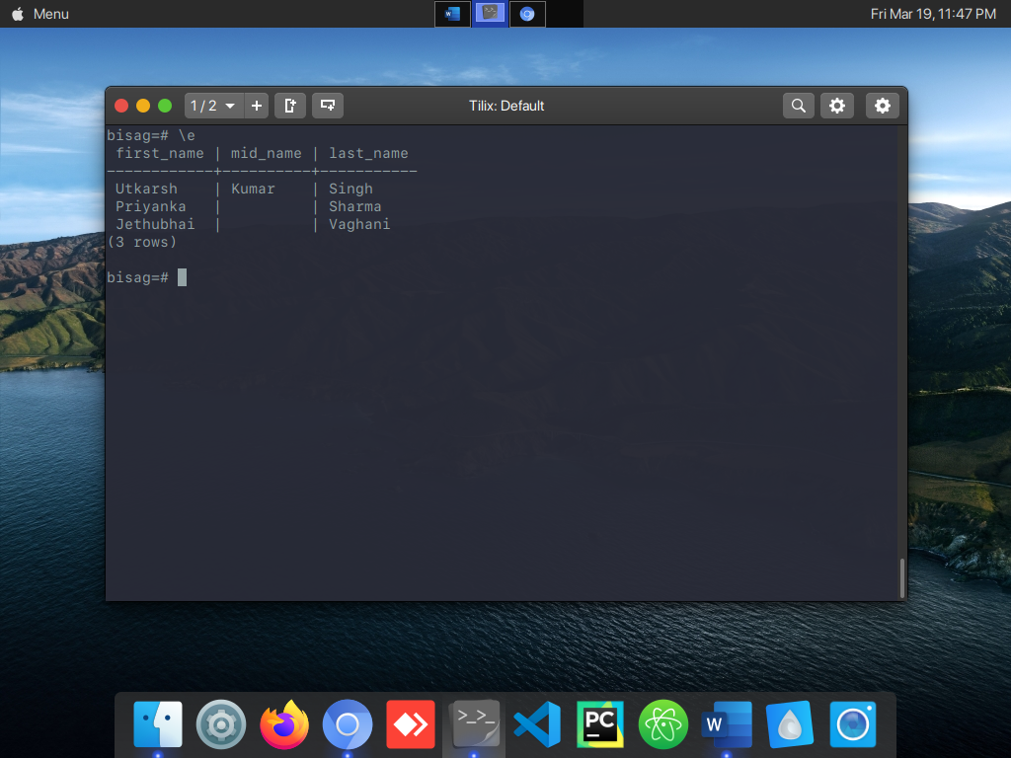

19. List of the employees whose name starts with ‘M’ and with 5 Characters in their name.

**select e.first_name, e.mid_name, e.last_name**

**from employee as e**

**where e.first_name like 'M____';**

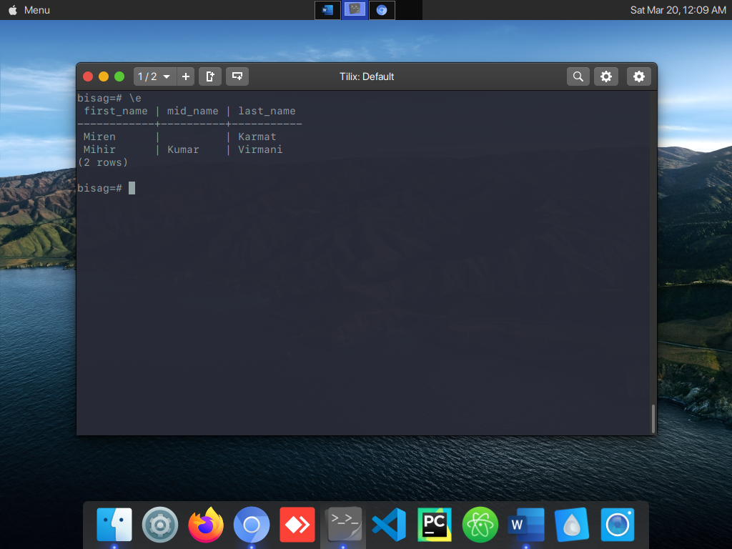

20. List of the employees whose name having 5 Characters in name, 2nd Character must be ‘I’ and end character to be ‘L’.

**select e.first_name, e.mid_name, e.last_name**

**from employee as e**

**where e.first_name like '_i%__l';**

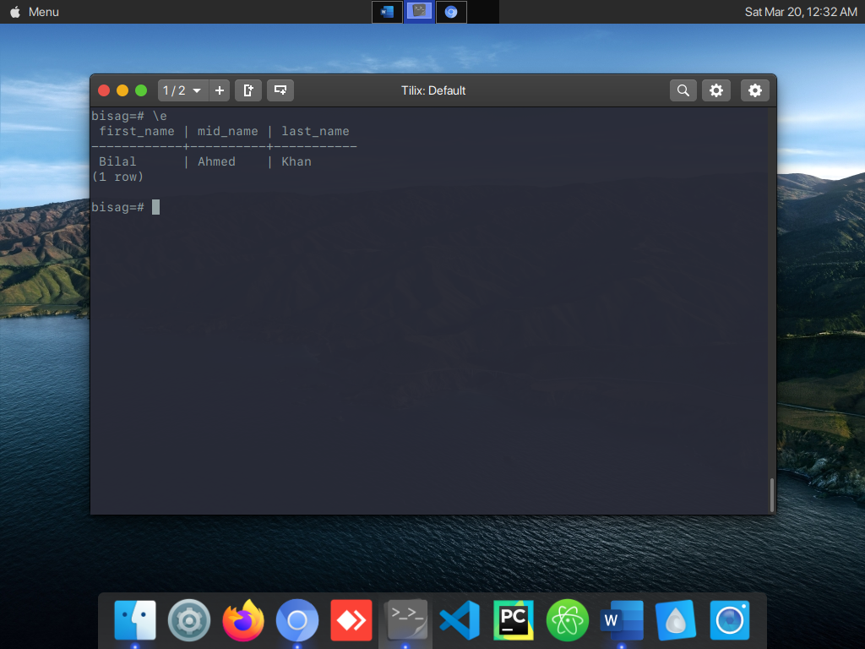

21. List all the employees with thier Designation as a team lead/Senior developer in Ascending Order.

**select e.first_name, e.mid_name, e.last_name, desg.name**

**from employee as e**

**join desg on e.desg_id = desg.id**

**where desg.name = 'Team Lead' or desg.name = 'Senior Developer';**

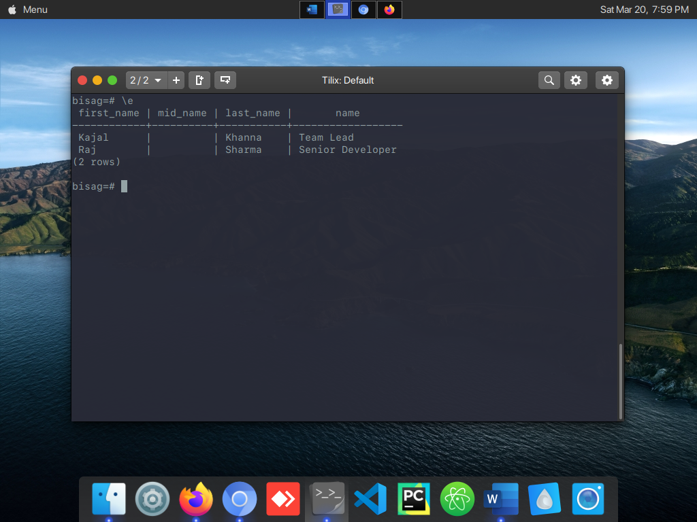

22. List all the Detail of employees like Age, Salary, Experience who are from Ethos and

Ncog and having experience more than one year.

**select e.first_name, e.mid_name, e.last_name, extract(year from age(current_date,**

**dob)) as age,**

**e.salary, deptt.name, extract(year from age(current_date, doj)) as total_exp**

**from employee as e**

**join deptt on e.deptt_id = deptt.id**

**where extract(year from age(current_date, dob)) > 1 and (deptt.name =**

**'Ethos' or**

**deptt.name = 'Ncog');**

**OR**

**select e.first_name, e.mid_name, e.last_name, extract(year from age(current_date, dob)) as age,**

**e.salary, deptt.name, extract(year from age(current_date, doj)) as total_exp**

**from employee as e, deptt**

**where e.deptt_id = deptt.id and**

**extract(year from age(current_date, dob)) > 1 and (deptt.name = 'Ethos' or**

**deptt.name = 'Ncog');**

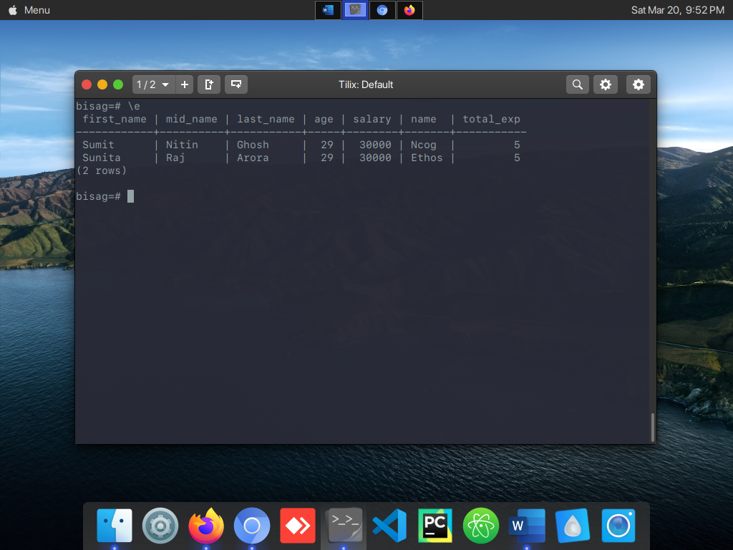

23. List all the Employees whose Name Start with (A,M,K,P) and end with (N,L,H) in Descending Order.

**select e.first_name, e.mid_name, e.last_name**

**from employee as e**

**where (e.first_name like 'A%' or e.first_name like 'M%' or**

**e.first_name like 'K%' or e.first_name like 'P%') and**

**(e.first_name like '%n' or e.first_name like '%l' or e.first_name like '%h')**

**order by e.first_name desc;**

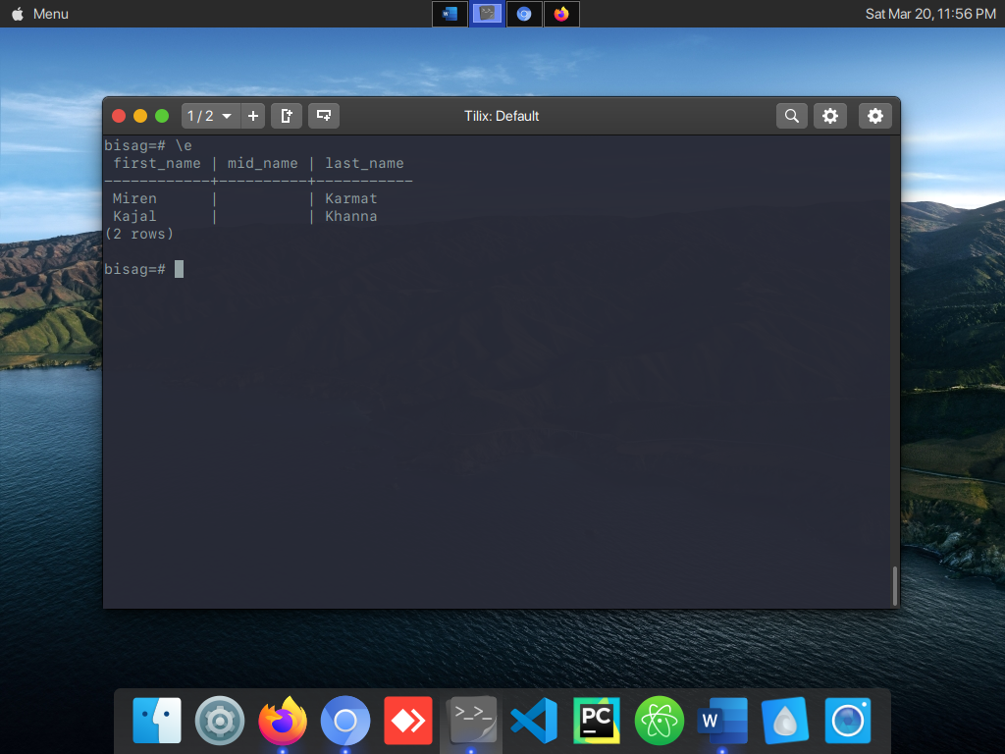

24. Find the number of counts of Employees in all Projects(Project wise count of employees).

**select p.name as "Project Name", count(e.id) as "Team Size"**

**from project as p, employee as e**

**where p.id = e.proj_id**

**group by p.name**

**order by p.name asc;**

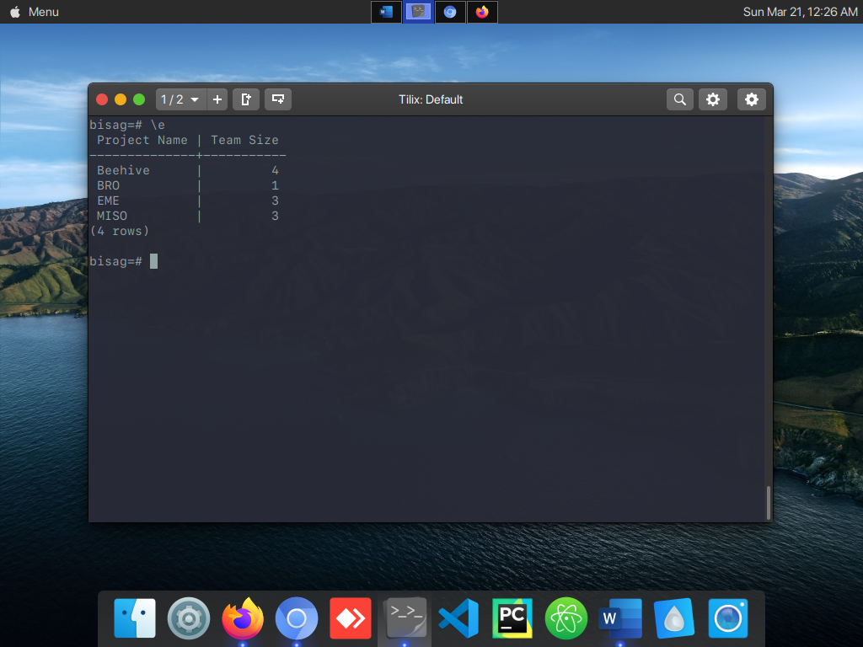

25. Write a SQL query to fetch Details Project Name,Employee name whose Designation is Team Leaders and counts of Employee under them.